**P.SESHA HARSHINI**

**1NT19IS107**

**Dt:26-04-2022.**

Aggregation pipelines.

db.names.find()

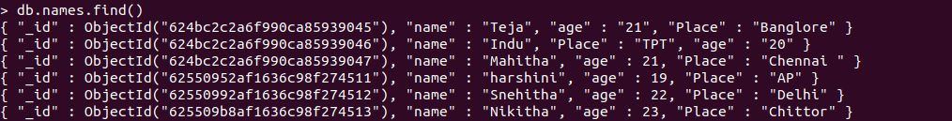

Count:

db.names.aggregate([{$match:{age:22}},{$count:"Total people with age:22"}])



Sum:

db.names.aggregate([{$match:{}},{$group:{_id:null,sum:{$sum:"$age"}}}])



Min:(row wise)

db.names.aggregate([{$group:{_id:"$name",minage:{$min:"$age"}}}])

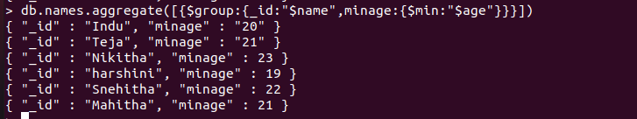

Min and Max values are same because we have only one value for age.

Max:(row wise)

db.names.aggregate([{$group:{_id:"$name",maxage:{$max:"$age"}}}])



Min(column wise):

db.names.aggregate([{$match:{}},{$group:{_id:"age",aggregate_age:{$min:"$age"}}}])



Max(Column wise):

db.names.aggregate([{$match:{}},{$group:{_id:"age",aggregate_age:{$max:"$age"}}}])

As “21” is the maximum value it prints “21”.



First value:

db.names.aggregate([{$match:{}},{$group:{_id:"age",aggregate_age:{$first:"$age"}}}])



Last value:

db.names.aggregate([{$match:{}},{$group:{_id:"age",aggregate_age:{$last:"$age"}}}])



Average:

db.names.aggregate([{$match:{}},{$group:{_id:null,avg:{$avg:"$age"}}}])

